Throughput Controller

It controls the loop from thread group .

If thread group loop is 10 times to execute , if throughput controller value is 5..it stops the execution at exactly 5 loops…

Throughput controls the looping execution.

Example:

LOOP COUNT =10

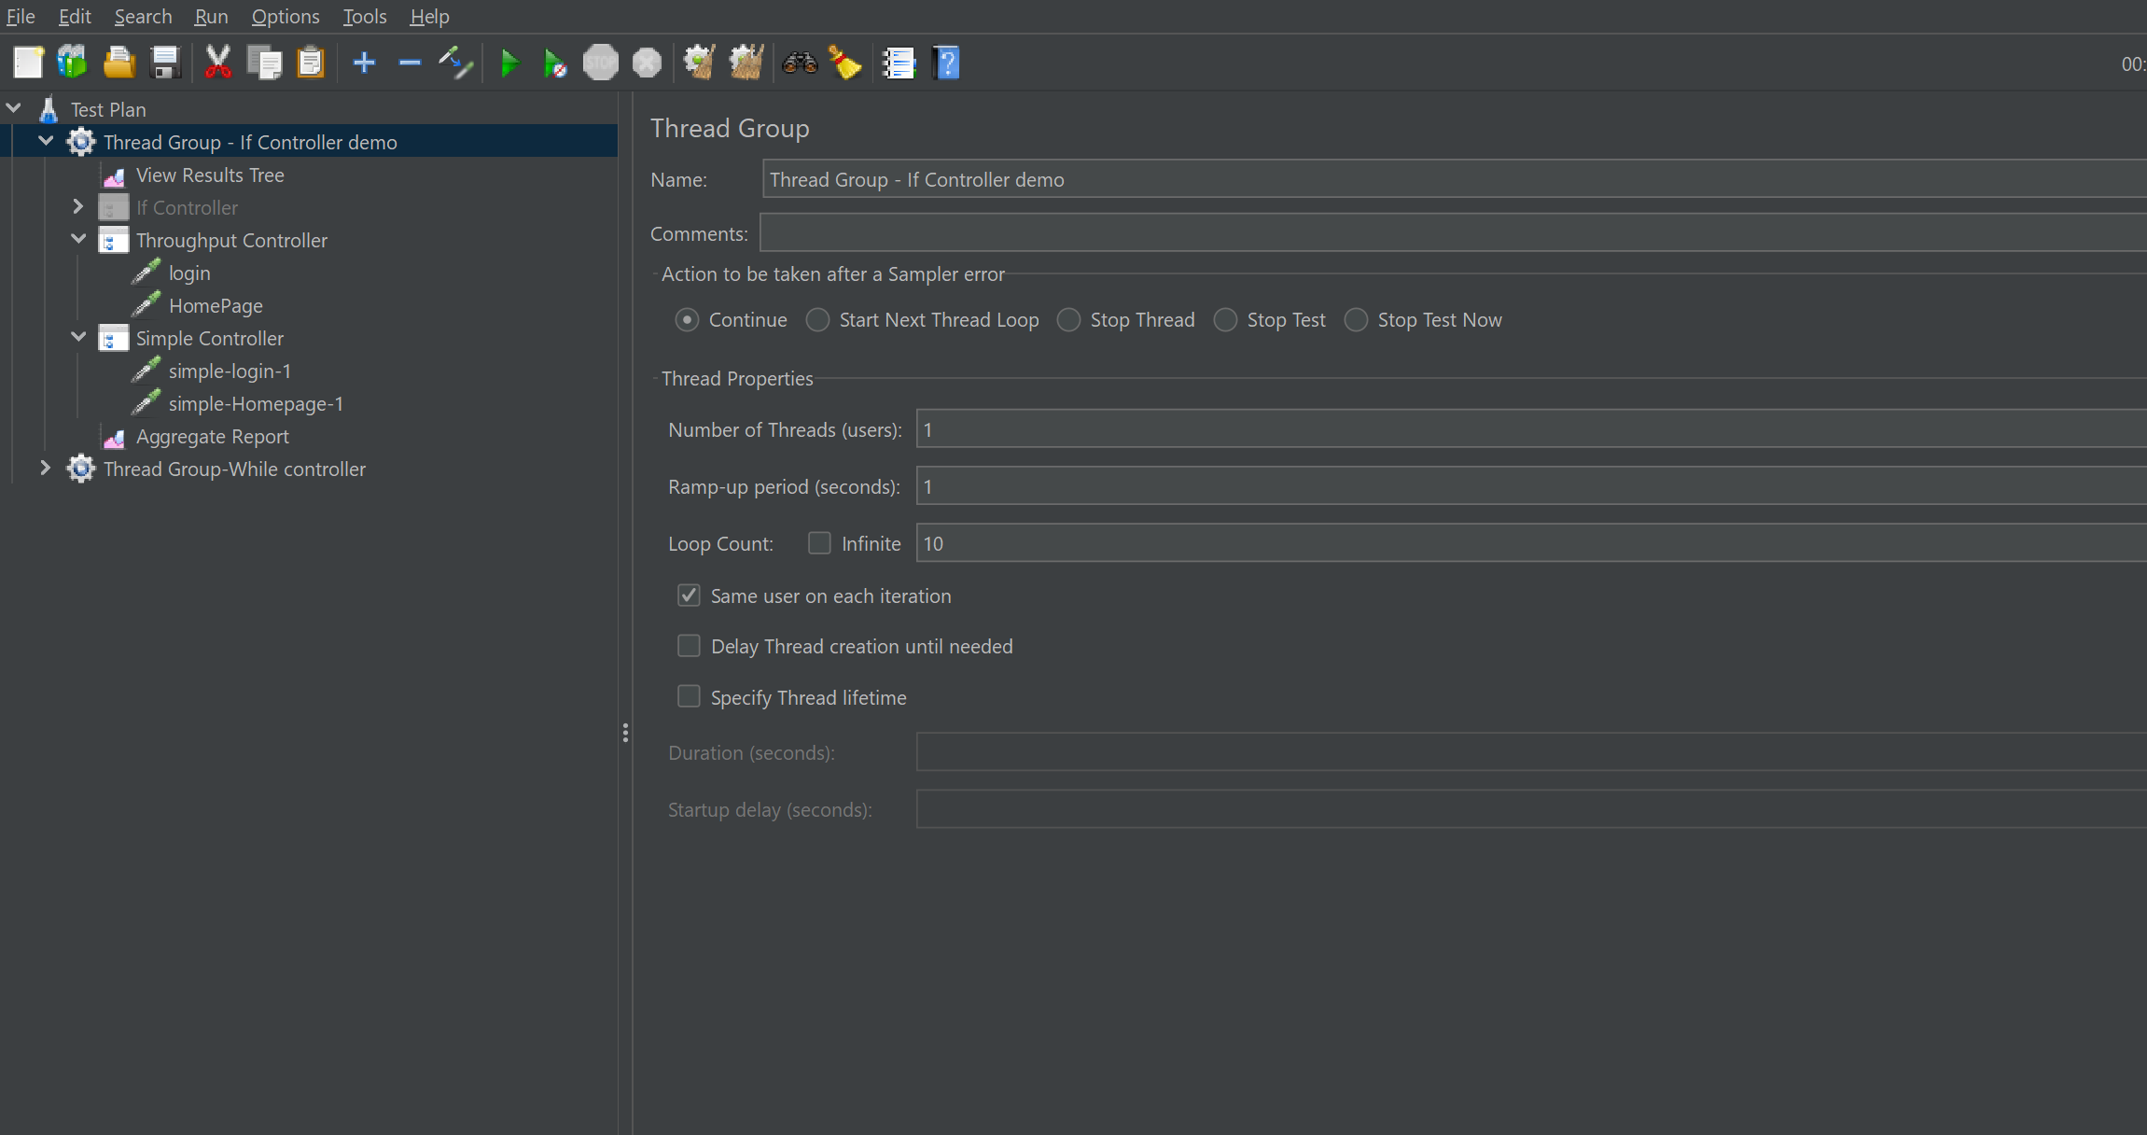

Given Through put =5.

Created Homepage and loginpage.

And created Simple Controller for login1 and homepage 2.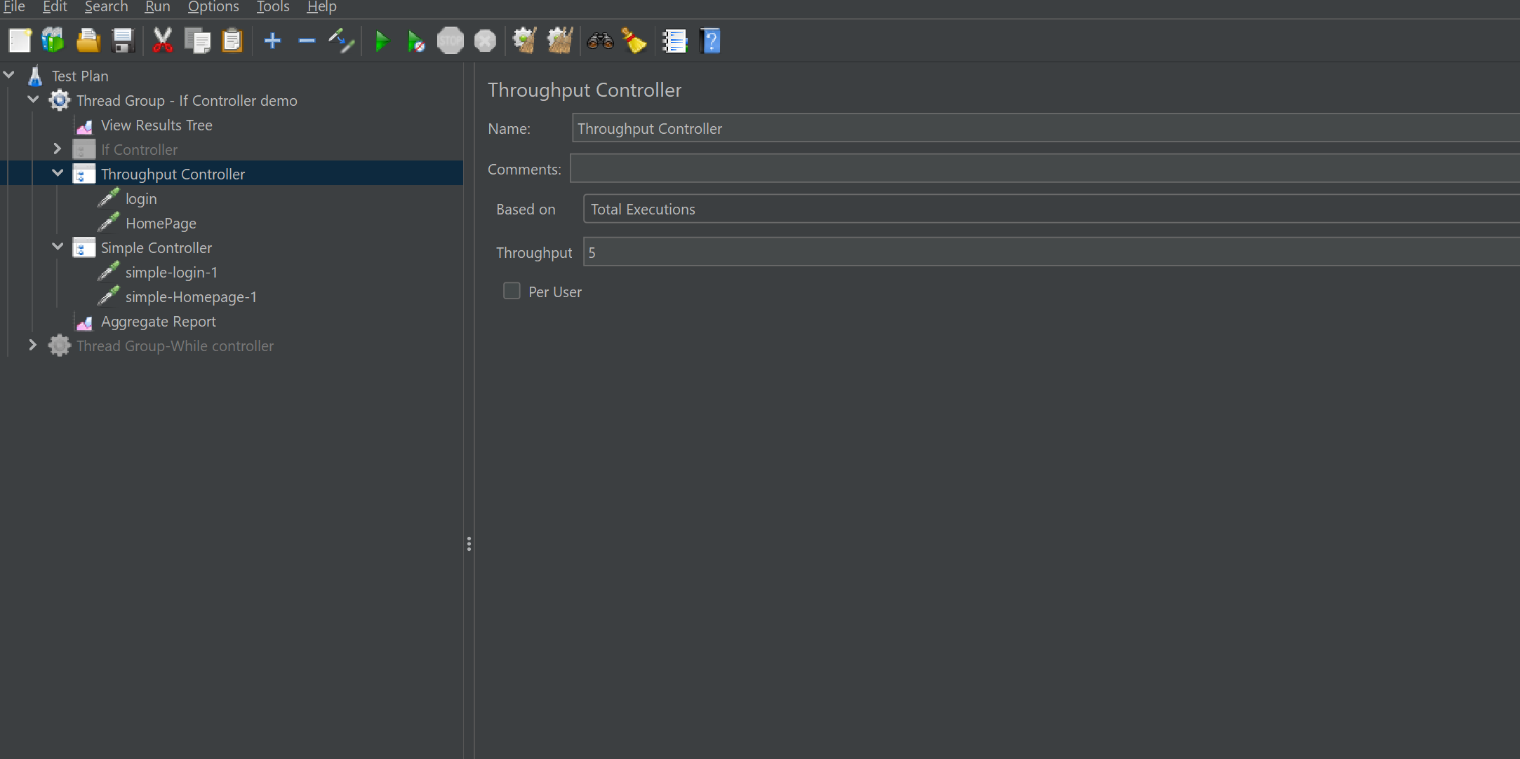

Below Output shows..Throughput executes Login and Homepage 5 times ….Simple Controller Executes 10 times.

